Massachusetts Alliance Against Predatory Lending
Member Group Priorities

2020 MORTGAGING & FORECLOSURE LEGISLATION

74,048+ Massachusetts households’ foreclosures and resultant harms (from Warren Group data)
Overpriced mortgage payments were unsustain-able, especially once housing prices dropped. Evidence shows not only well-publicized, widespread robo-signing, but mortgage originators who went out of business — with no legal transfer of their loans, forged notes. Now we see “foreclosures” of all types of borrowers on unenforceable debt.

We need fundamental solutions now!
2019 homeowner evidence shows banks chose a 2+ month moratorium in our state; but then pre-foreclosure notices doubled in 2nd half of 2019!

While rampant subprime mortgage lending attracted worldwide investment, its incentivizing led to vastly overpriced homes with illegal originations ultimately doomed to fail! Massachusetts is still paying for the snowballing foreclosures and property losses this over-pricing and peaking of housing values produced. See this graph from the Boston Federal Reserve:

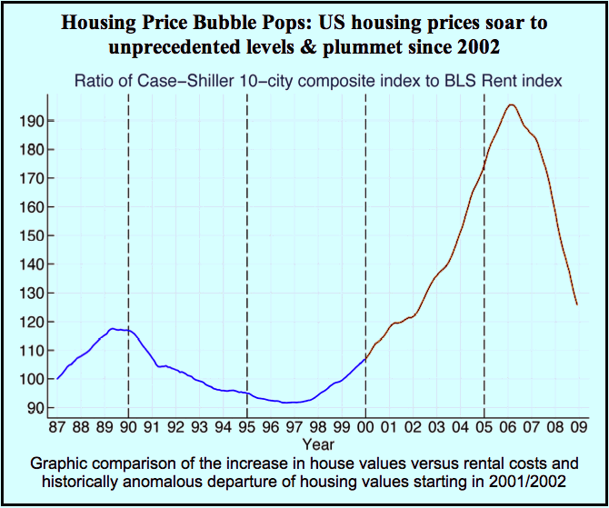

Massachusetts can lead. We can provide the tools to unravel this mess – fairly and while returning billions of dollars to our state. How…?

- Require Pre-Foreclosure Mediation/Judicial Foreclosure, S868/H1482: Sen Collins, Rep Khan

For two months around March of 2019, the Mortgage Industry had a statewide, voluntary (& almost perfect) moratorium on foreclosure auctions (homeowners figured out how to exercise their right to see the original mortgage Note pre-foreclosure – when 58 out of 60 Notes viewed were forgeries). Just prior, this Bill was filed to stop all foreclosures where pre-foreclosure mediation has not been completed "in good faith," and to allow judicial foreclosure only. The foreclosing party must provide legal documents proving it actually owns both mortgage and Note, and send a representative with full authority to negotiate settlements. When the City of Lynn had such a mediation program, 97% of participants voluntarily negotiated an affordable loan modification.

- Foreclosure Review Division of Superior Court, S964/H3300: Sen. Kennedy & Rep. Gonzalez

This Bill establishes a statewide, specialized division of Superior Court to adjudicate all aspects of foreclosure-related cases, instead of several courts each now with partial jurisdiction. Housing Courts (without the time per case, nor applicable expertise nor jurisdiction) are ignoring settled law to rush illegally foreclosed families out of their homes. This Division will be empowered to clear title for both those “foreclosed” and 3rd-party buyers, while providing on-line and other assistance to pro se (self-represented) litigants. It will free up court dockets; promote judicial economy; and restore clear title to illegally foreclosed homes, bolstering the real estate industry.

- Tax Relief of Mortgage Debt, S1719/ H2550: Sen. DiDomenico and Rep. Malia

When a homeowner’s mortgage ends in foreclosure, tax law regards that debt as paid off at foreclosure as “income” to homeowners who just lost their home and likely largest investment of their lives. Congress changed federal tax law to exempt homeowners from being taxed as if that is income. This Bill creates the same tax exemption at the state level. Two sessions have reported out this bill without final passage; meanwhile 10,000+ homeowners have faced state income taxes that most cannot repay -- on money they never received.

- Preventing Unnecessary Vacancies, S931/H1373: Sen. Eldridge and Reps. Capano & Cahill

This Bill requires a commercial purchaser of a legally foreclosed home to rent it to the “foreclosed” homeowner until the property is sold to a new owner-occupant. The former owners become tenants paying the HUD fair market rent for their units. Post-foreclosure tenants can be evicted only for just cause.

- Real Estate Title Protection Act, H1524: Rep. Frank Moran

This Bill protects real estate titles. With it, the mortgagor (borrower) can always tell who owns the mortgage. It also requires the Mortgage Note to be returned to the mortgagor, marked “Paid in Full,” upon payoff. It requires Registries of Deeds to record each mortgage in the names of the real parties in interest, i.e., mortgagor and lender as defined in consumer law and the Common law. It institutes deadlines for recording assignments of mortgage and foreclosure deeds. By protecting marketable title, it bolsters business creation via entrepreneurs’ mortgages on their own homes: which historically have provided up to 70% of the credit for new U.S. businesses.

- Property Tax Taking of Home, S1722/H2549: Sen. Montigny and Rep. Mahoney

Municipalities have often allowed delinquent owners to pay real estate taxes late or make long payment plans. Now, 31 municipalities instead sell their tax title debt to unregulated individuals. Owners are unaware that once third party investors foreclose on their homes in Land Court, their homes cannot be redeemed. This Bill requires: (1) explicit notices to homeowners with an alert in the 5 most common languages other than English; (2) licensing tax title purchasers as debt collectors; (3) 1 year redemption period after Land Court foreclosure; (4) that a third-party tax title buyer who forecloses in Land Court must auction the property publicly, with net proceeds split between the municipality and past owner.

- Judicial Foreclosure, S836/H3384: Senator Brady and Rep. Mark

This Bill requires 1 – 4 family home foreclosures to be conducted through a court action. A party wishing to foreclose must provide the legal documentation to prove to a judge that it holds the mortgage and Note (or acts for Note Holder before it forecloses). With Massachusetts’ present, non-judicial foreclosure practice, a wronged homeowner must get a judge to order the foreclosing party to produce this evidence. Judicial Foreclosure will prevent foreclosures by those with no authority to foreclose, and prevent clouds on title presently created during non-judicial foreclosures.

- Resolution Trust Fund, S566/H961: Rep. DuBois

This Bill establishes a dedicated, state Trust Fund into which borrowers pay when they prove no bank can legally claim their mortgage. Recent cases show hundreds of Massachusetts mortgages lack a legal owner and should revert to the State, but we lack a mechanism to receive mortgage payments. Annual statewide hearings would determine use of revenues to rebuild housing and businesses in areas hard hit by foreclosures. As funds increase, hearings will be held regionally and the monies used to rehabilitate the areas from which they originate.

maaplinfo@yahoo.com www.MAAPL.info Legislative Contact: Grace Ross, 617-291-5591

MAAPL Members/Supporting Organizations: Action for Boston Community Development, Inc., Action for Regional Equity, Alliance of Providers of Legal Services to Individuals Facing Foreclosure, ARISE for Social Justice, Arlington Community Trabajando, Boston Tenants Coalition, Brazilian Women's Group, Brockton Interfaith Community, Carpenters Local 40, Carpenters Local 107, Charles Hamilton Houston Institute For Race & Justice, Chelsea Collaborative, Chinese Progressive Association, City Life/Vida Urbana, Coalition for Social Justice, Community Economic Development Ctr of S.E. MA, Community Labor United, Democratic Socialists of America, Dorchester People for Peace, Era Key Realty Services, ESAC, Fair Housing Center of Greater Boston, Greater Boston Legal Services, Greater Four Corners Action Coalition, Green-Rainbow Party of MA, Harvard Legal Aid Bureau, Homeowner Options for MA Elders, Jewish Alliance for Law and Social Action, Lawrence Community Works, Lawyers' Committee for Civil Rights Under Law, Lynn United for Change, Legal Assistance Corporation of Central Mass, Mass Advocates for Children, Mass AFL-CIO, Mass Coalition for the Homeless, Mass Community Action Network, Massachusetts Fair Housing Center, Mass Jobs With Justice, Mass Law Reform Institute, Mass Welfare Rights Union, Merrimack Valley Labor Council, NAACP N.E. Area Council, National Community Reinvestment Coalition, National Consumer Law Center, National Lawyers Guild, Neighbor-to-Neighbor, Neighborhood Legal Services, New England United for Justice, North Shore Labor Council, Organization for a New Equality, Painters District Council 35, Pleasant St. Neighborhood Network Center, Southbridge Community Connections, Springfield No One Leaves Coalition, Survivors Inc., UE Northeast Region, Union of Minority Neighborhoods, United Auto Workers Mass CAP, United Food & Commercial Workers 1445, United For a Fair Economy, United Steel Workers Local 5696, Volunteer Lawyers Project, Worcester Anti-Foreclosure Team

